A series of articles by David Harris as he observes

Luthier Jan Shelley at work…

FROM THE OTHER SIDE OF THE BENCH

Mending a soundpost crack in the back of a French ‘Cello.

Introduction
Traditionally, the classic soundpost crack repair has involved fitting a quite large “patch” made of maple into the inner surface of the back of the instrument with the grain running in the same direction as the back. This traditional patch is of the order of 5x10cm. in size, and offers little in the way of strength because of the grain direction of the patch. Jan’s method is to fit a much smaller piece of maple at the position of the sound post, which is no larger than necessary, and disperses the load at 90° to the line of the crack.

Traditional Improved
Grain direction of back
Grain direction of patch
Patch

Soundpost
Diagram showing
The “footprint” of
the two patch
designs.

The line of the crack can be seen above the pencil point

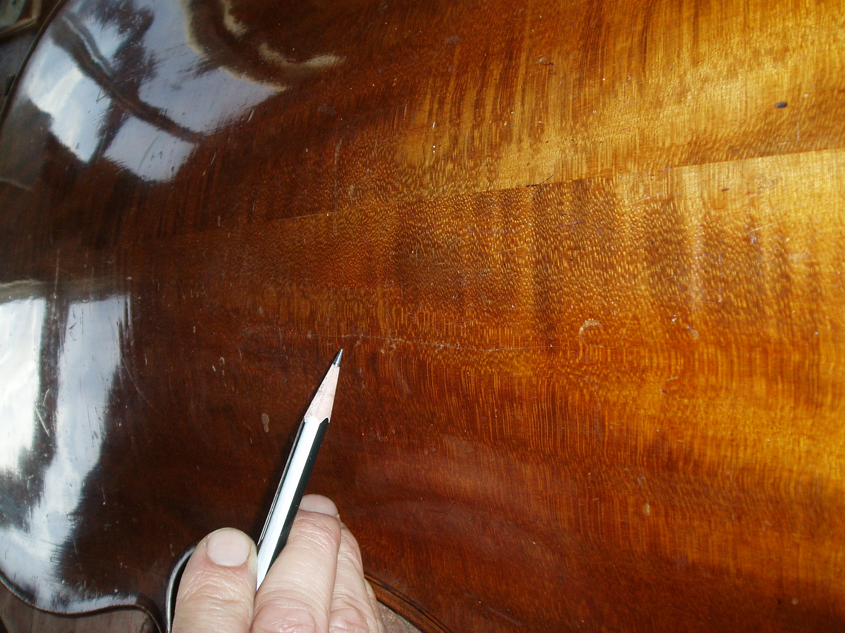

The back is first removed, and the inside surface cleaned to remove dust and the integrity of the studs are checked. A loose stud is found and removed. The crack is first cleaned and glued prior to the work commencing on the patch.

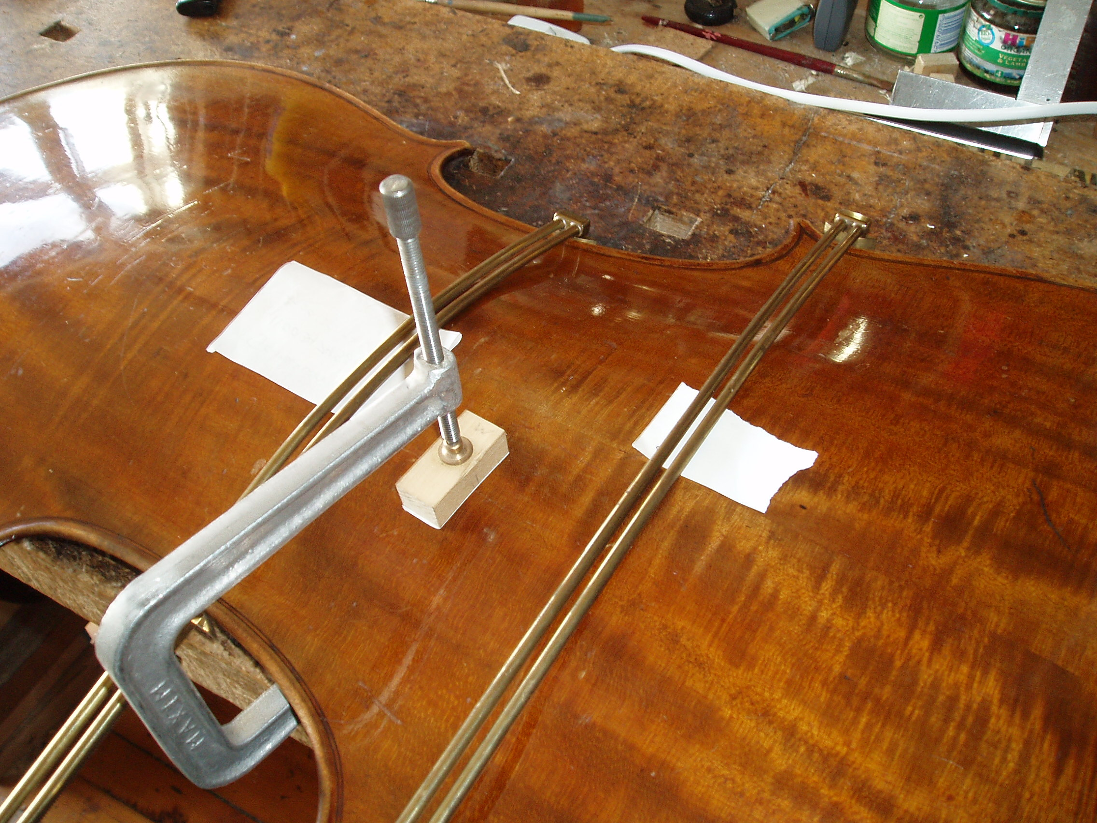

The position of the patch is then determined by careful measurement, and this measurement transferred to the inside of the back.

The thickness of the back plate at this position is measured with callipers and found to be 5.4mm. The aim is now to gouge a channel of the order of 3.5mm. deep at this location.

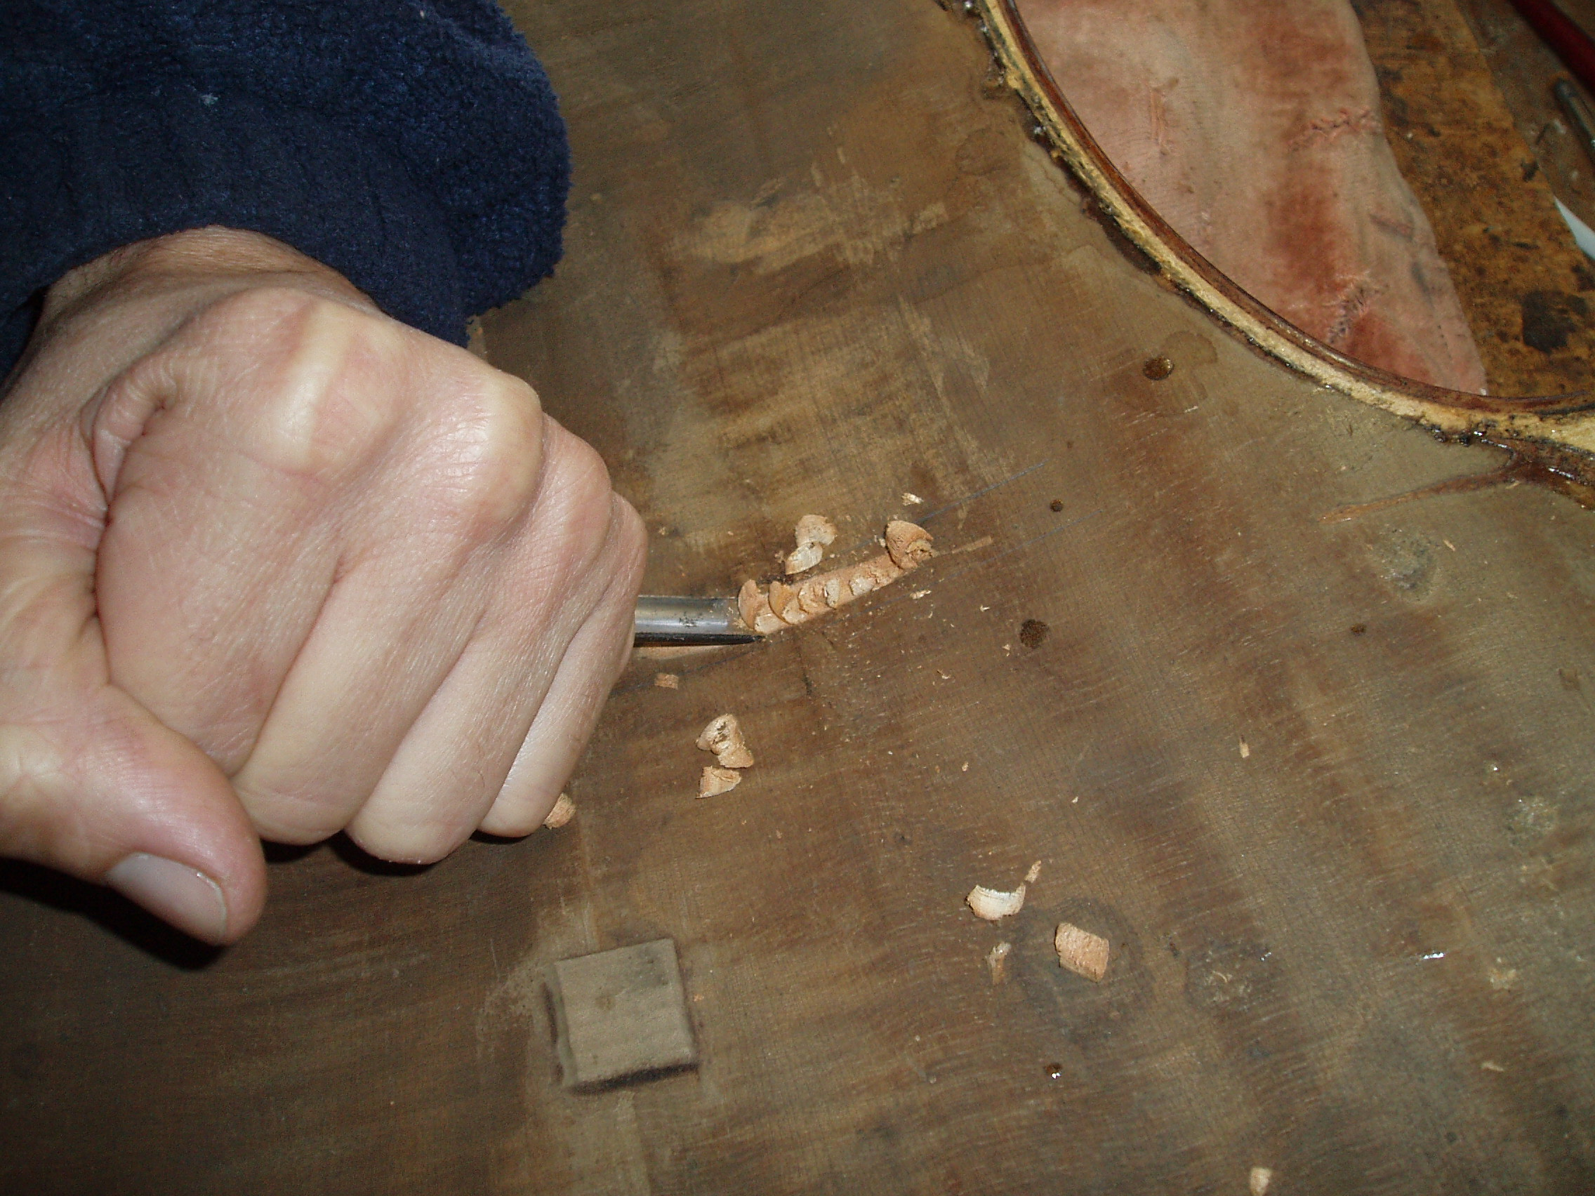

The gouges used are No. 7 and No. 8 outside ground. Wood is carefully removed to a maximum depth of 3.5mm. at the deepest point. The finished cut is shown below.

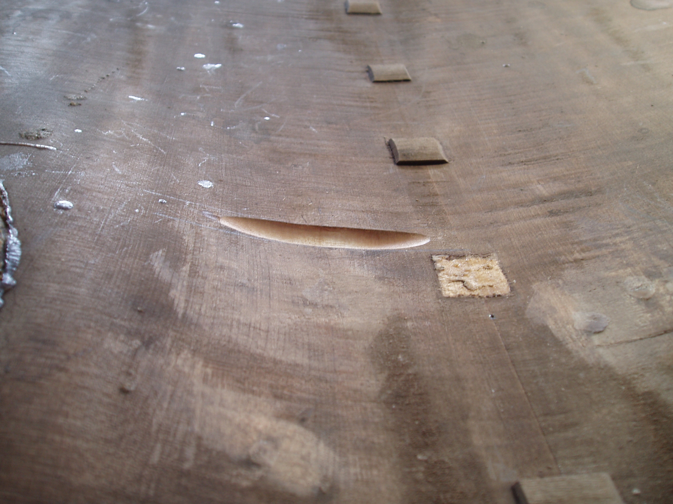

Next, a tracing of the outline of the cut is made and transferred to a piece of quarter sawn maple.

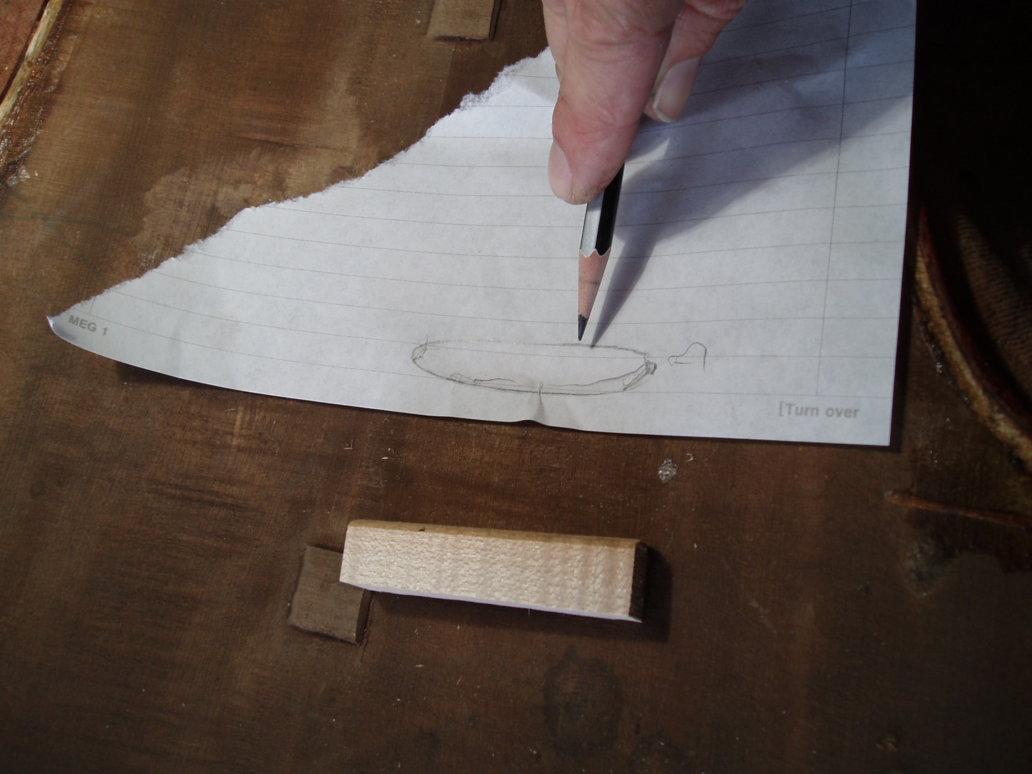

The piece of maple is then cut out, shaped roughly using a rasp, and finally chalk fitted to the exact shape of the cut.

